DCP AQuIP Toolkit

Social Media Advertising Methods
Social media outreach is a fast and effective way to recruit participants and works well when combined with traditional advertising methods. Use social media to:
- Connect with online populations
- Engage discussions
- Raise cancer prevention awareness
Learn how to utilize both options to reach the target audience. Each site has a basic setup:
- Create a centralized profile with the organization/trial name, contact information, and trial information.
- Select audience demographics and advertising avenues, and methods for interacting with
the audience.
Some social media platforms even include the ability to link services together. For example, Facebook can highlight tweets from a Twitter account on a Facebook page. Include links between various social media platforms in the biography section of each platform. In addition, data on how customers engage with trial ads can be accurate and easy to track.
Find an audience, create awareness, and engage the audience on one or more of these sites:
Facebook
www.facebook.com
Twitter
www.twitter.com
LinkedIn
www.linkedin.com

Moderating Social Media Platforms

Proper guidance is needed to define appropriate use of social media by site staff. Please review the HHS regulations at 21 CFR Part 56 and 45 CFR Part 46, FDA Recruiting Study Subjects Information Sheet and the NIH Guidance Regarding Social Media Tools for more information.

Each social media site has privacy settings to limit, hide, or stop user interaction. Review the steps on pages 5, 8, and 11 of this template for each social media platform settings to fully moderate the page.

When posting to social media, IRB approval is required for any post or discussion which goes beyond these six topics:

- Trial title
- Purpose of the trial
- Protocol summary
- Basic eligibility criteria
- Trial site locations
- Contact information

When responding to a user post/comment beyond the six topics, it is suggested the conversation with the user is channeled off the social media page and continued by phone
or email.

Use the following template in site comments to take a conversation off the social media site.

[Insert “Thank you for your comment” or Thank you for your concern”] Please contact us at
1-800-123-4567 or email us at mail@xyzclinic.com to speak with one of our representatives.

Facebook Advertising

Unpaid Advertising
Advertising through Facebook begins by creating a Facebook business page for the trial. This page brands the trial, distributes trial information and drives traffic to a recruiting site. Creating a page involves creating a profile photo and a biography, and choosing search engine descriptions. Go to https://www.facebook.com/business/ and follow the instructions on the “Create Page” link.
Facebook offers six categories to brand a website, however only one applies to clinical trials:
- Causes or Communities
Once a page is set up, begin uploading posts and photos to the trial. Here is a recommended template and sample of information to include in both unpaid page posts and paid ads.

Template
[Insert Tagline] [Insert Positioning Text]

[Insert Picture] and/or [Insert Video]

[Insert Call to Action]

Sample:
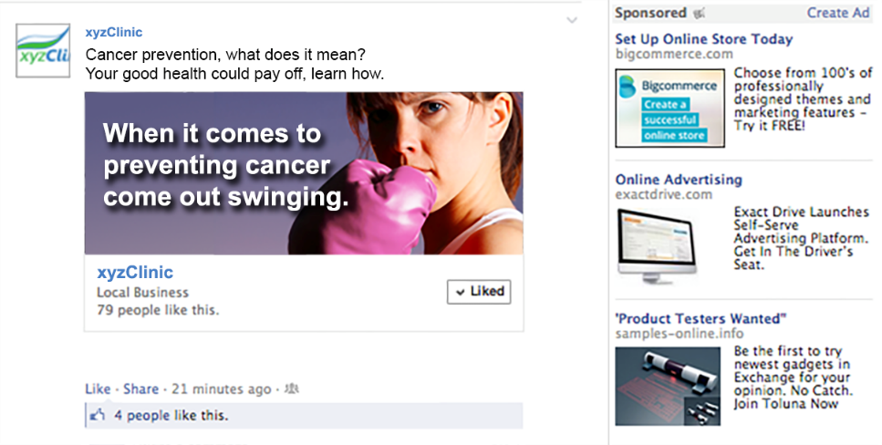

Paid Advertising
Once a page is set up, choose the ad campaign which best suits the trial. As more people like the page, the more extensive the reach becomes. Some Facebook ads are better for getting page likes and raising awareness, while others are preferable to drive traffic, or start conversations. Facebook offers nine paid advertising campaigns; use the following four:
- Clicks to Websites – Get the audience to visit a website.
- Page Post Engagement – Promoting page posts.
- Page Likes – Get page likes to grow the audience and build a brand.
- Video Views – Tell a story using a video in an ad.
Facebook ads can be formatted in three locations. Each location has different specifications for image sizes, characters for text, and placement on the website. The types of ads available are:
- Newsfeed Advertisements
- Facebook Mobile New Feed Advertisements
- Right Hand Column Advertisements
Following this choice, the trial must indicate the budget to use for advertising, and choose the audience based on:
- Location
- Age Interests
- Gender
- Languages
- Education Level
- Relationship Status
- Political Views
Connections to other Facebook pages Learn more information regarding image sizes, recommended characters for text, and tips at www.facebook.com/business/ads-guide.

Moderating Facebook Pages

Facebook presents two filtering options which proactively block words and profanity, or moderates and block users/user comments once they have interacted with the Facebook page.

To proactively block words:

- Click ‘Settings’ at the top of the page.
- Click ‘Page Moderation’.
- Type the words to block, separated by commas. Add both the singular and plural forms of the word to be blocked.
- Click ‘Save Changes’.

To proactively filter profanity:

- Click ‘Settings’ at the top of the page.
- Click ‘Profanity Filter’.
- Select ‘Medium’ or ‘Strong’.
- Click ‘Save Changes’.

To manage follower settings:
- Go to ‘Settings’.
- Click ‘Followers’ in the left column.
- Click ‘Follower Comments’ to select who can comment on public posts.
- Click ‘Follower Notifications’ to select who should receive notifications when people start following and sharing the page and like or comment on public posts.

To block a user:
- Click the ‘Lock Icon’ at the top right of any Facebook page.
- Click ‘How do I stop someone from bothering me?’
- Enter the name or email address of the person to be blocked and click ‘Block’.
- When entering a name, select the specific person to be blocked from the list
that appears.
- After clicking on ‘Settings’ select ‘Moderate’.

For more information visit www.facebook.com/help/.

Twitter Advertising

Unpaid Advertising
Advertising through Twitter begins by creating a Twitter account. This account brands the trial, distributes trial information and drives traffic to a recruiting site. Creating an account involves creating a profile photo, a header image, and biography, choosing a user name which will be the unique identifier of the trial, and adding a link to the trial recruitment website.
The biography should include:
- Phone numbers
- Web links
- Email addresses
- Additional contact information
After creating a Twitter profile, begin tweeting information regarding the trial. Tweet regularly using various slogans and call to action tags to spread information regarding the trial. Tweet actively to raise awareness, retweet and converse with followers to keep the audience engaged, and use appropriate hashtags to increase reach.
All tweets must follow the same format and must be 140 characters or less. Tweets can also be sent out in a series to communicate more information, but be sure that each tweet can stand on its own. Use the following template to design tweets. Mix and match elements to create a clear message.

Template:
[Insert Tagline] and/or [Insert Positioning/Supporting Text] and/or [Insert Call to Action] and/or [Insert Picture] and/or [Insert Video Link] [Insert Hashtags]
Samples:
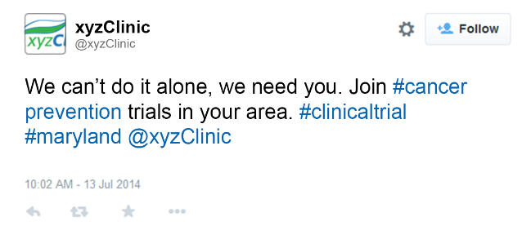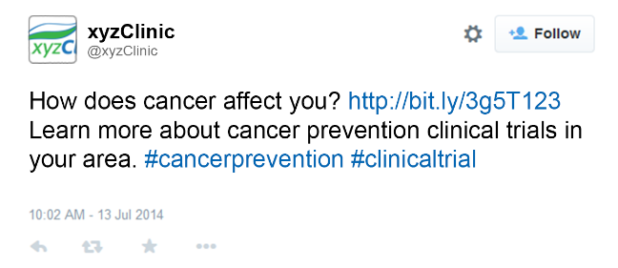

Paid Advertising
Posted Tweets are only available to followers; however, the audience can be expanded by paying for tweets. First, decide what type of advertising campaign to run. To raise awareness, use the following campaigns:
- Followers – Grow a Twitter community.
- Tweet Engagements – Reach more people and drive conversation.
- Leads on Twitter – Collect emails from audiences who express interest.
- Website Clicks and Conversations – Drive traffic to the trial site.
More information about paid advertising is available at https://business.twitter.com/solutions/

Hashtag [#] Suggestions:

- Cancer
- Clinical Trial
- Prevention
- DCP
- NIH
- City or Region
- CLO or PO Name

More information on Twitter basics and advertising options is available at www.business.twitter.com.

Moderating Twitter Accounts

Public versus Protected Tweets

Twitter allows a tweet be public or protected. Accounts with protected tweets require manual approval of each and every person who may view tweets from that specific account. Public tweets are visible to anyone; protected tweets may only be visible to approved Twitter followers after manual approval. When tweets are protected, users must request permission to follow. In addition, users will not be able to retweet or quote protected tweets.

To protect tweets:

- Go to ‘Security’ and ‘Privacy Settings’.
- Scroll down to the ‘Tweet privacy’ section and check the box next to ‘Protect my Tweets’.
- Click the blue ‘Save’ button at the bottom of the page. Enter the account password to confirm
the change.
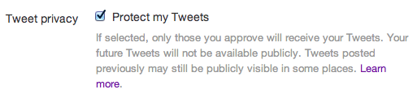

To block a user from commenting on a tweet:

- From a Tweet, click the ‘More Icon’ (•••) at the bottom of the Tweet.
- Click ‘Block’.

To block a user from commenting on a profile:

- Go to the profile page of the account to be blocked.
- Click the ‘Gear Icon’ on their profile page.
- Select ‘Block’ from the menu.
- Click ‘Block’ to confirm.

For more information visit www.support.twitter.com/.

LinkedIn

Unpaid Advertising
If a LinkedIn page for the site does not already exist, follow this link www.business.LinkedIn.com and create a profile. Use this page to develop an identity for the trial among the LinkedIn community.
Create an organizational profile and then posting information regarding the trial.
Paid Advertising
Go to LinkedIn Ads www.LinkedIn.com/ads and select ‘Get started’. This will present the four step process to create a LinkedIn ad.
- Fill out the following information to set up the advertising campaign. There are six sections that need to be completed.
- Campaign Name – Create a name for the campaign.
- Ad Language – Select the language for the ad.
- Media Type – Select either a basic ad or video ad.
- Ad Destination – Link ad to either a LinkedIn profile page or an external URL. When driving traffic to the website, tag URLs to measure the engagement and quality of traffic.
- Ad Design – Create a headline and a description.
- Ad Variations – Create multiple variations of ads. For each ad, select either an external URL or a page on LinkedIn.
- Target the audience by:

- Job Title
- Employer
- Industry
- Skills/ interests
Be sure to understand audience size, as it is different from possible impressions or metrics used by other networks. If it is determined the audience size is getting too small, use LinkedIn’s suggested options to recommend audiences based on similar keywords in the ad.
LinkedIn advertising has the ability to turn on ‘Lead Collection’. This feature allows users who engage with the ad to send contact info and give permission to be contacted.

- Establish a budget for advertising. LinkedIn offers two basic pricing models:

- Cost per click (CPC)
- Cost per 1,000 impressions (CPM)
Use the option that will have the greatest impact on driving audience traffic to the website.
- Submit the ad by clicking on ‘Launch Campaign’.
LinkedIn reviews almost all ads manually, so the campaign will not appear online until it goes through a quick review process.
Find out more information on LinkedIn basics and advertising at www.LinkedIn.com/ads.
Sample:
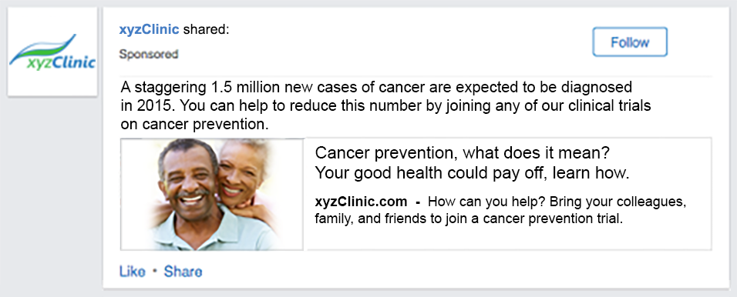

Moderating LinkedIn Accounts

LinkedIn presents the option to block users interact with the site and delete comments from the LinkedIn page.

To block a user on LinkedIn:

- Navigate to the users profile and click the drop-down menu next to the button in the top section of the member's profile (this button may have different names depending on the account type).
- Select ‘Block’ or ‘Report’ next to the users name and click ‘Continue’.
- Click ‘Agree’ to confirm it.

To delete a comment:

- Click the ‘Discussion Title’ to view the full discussion.
- Click the ‘Delete’ link under the member's comment.

For more information visit www.help.linkedin.com/app/home.

